Topic: Emotion Detection from Text

Abstract
This microproject presents a hybrid deep learning architecture combining BERT-base-uncased with a bidirectional LSTM to perform emotion classification across six categories: anger, fear, joy, love, sadness, and surprise. The system includes preprocessing, tokenization, stratified sampling, model training, validation, and extensive evaluation. Final testing on 2,000 samples achieved 92.40% accuracy, macro-F1 of 0.8883, weighted F1 of 0.9257, and a Cohen’s Kappa score of 0.9006, indicating strong reliability.

Introduction
Emotion detection plays an important role in sentiment analysis, user modeling, and intelligent conversational systems. Transformer models like BERT have advanced the field by offering contextualized word embeddings, but adding sequential models such as BiLSTM enhances the capture of emotional progression within text. This project implements such a hybrid architecture and evaluates its performance on a standard NLP emotion dataset.

Dataset
We used the Emotion NLP Dataset containing sentences labeled with one of the six categories: anger, fear, joy, love, sadness, and surprise. The final evaluation used 2,000 samples from the validation split.

Preprocessing Pipeline
The preprocessing pipeline includes URL removal, HTML tag removal, demojization, hashtag/user-mention removal, repeated character normalization, ASCII filtering, whitespace normalization, and optional spelling correction. Lowercasing was applied for compatibility with BERT-base-uncased.

Tokenization
The BERT tokenizer (bert-base-uncased) was used with max_length=100, truncation, and padding. Attention masks were generated for all samples. Tokenized tensors were stored for reuse.

Model Architecture
The hybrid model integrates

BERT-base-uncased to produce contextualized

A BiLSTM layer with 128 hidden units to capture sequence-level emotional

A dropout layer for

A fully connected output

Training used AdamW with learning rate 2e-5, gradient clipping, and class-weighted loss.

Recent Papers on Similar Work:
- Abas, A. R., Elhenawy, I. M., Zidan, M., & Othman, M. S. (2021). BERT-CNN: A Deep Learning Model for Detecting Emotions from Text. Computers, Materials & Continua, 71(2), 2943-2961.
- Sahoo, A. K., & Kavya, R. V. (2024). Text-Based Emotion Detection: A Deep Learning Approach Using Big Data and Semantic Text Analysis for Human Emotion Detection. Proceedings of the 3rd International Conference on Optimization Techniques in the Field of Engineering (ICOFE-2024), Available at SSRN:
- D. Yohanes, “Emotion Detection in Textual Data Using Deep Learning,” Procedia Computer Science, vol. 217, pp. 138–149, 2023.
- Patel, P., Patel, D., & Bera, M. (2023). Emotion Detection in Text : A Deep Learning Approach for … International Journal of Novel Research and Development, 8 (10), (Paper ID IJNRD 2310156).
- Batbaatar, E., Li, M., & Ryu, K. H. (2019). Semantic-Emotion Neural Network for Emotion Recognition from Text. IEEE Access, 7, 111866-111878.
- Bharti, S. K., Varadhaganapathy, S., Gupta, R. K., Shukla, P. K., Bouye, M., Hingaa, S. K., & Mahmoud, A. (2022). Text-Based Emotion Recognition Using Deep Learning Approach. Computational Intelligence and Neuroscience, 2022, Article ID 2645381.
- Sahoo, A. K., & Kavya, R. V. (2024). Text-Based Emotion Detection: A Deep Learning Approach Using Big Data and Semantic Text Analysis for Human Emotion Detection. Proceedings of the 3rd International Conference on Optimization Techniques in the Field of Engineering (ICOFE-2024),
- Chutia, T., & Baruah, N. (2024). A review on emotion detection by using deep learning techniques. Artificial Intelligence Review, 57, 203.
- Machová, K., & Szabóová, M. (2023). Detection of emotion by text analysis using machine learning. Frontiers in Psychology, 14, 1190326.
- Bharti, S. K., Varadhaganapathy, S., Gupta, R. K., Shukla, P. K., Bouye, M., Hingaa, S. K., & Mahmoud, A. (2022). Text-Based Emotion Recognition Using Deep Learning Approach. Computational Intelligence and Neuroscience, 2022, 2645381.

Methodology
The methodology begins with loading and preparing the Emotion NLP Dataset, which contains sentences paired with emotion labels such as anger, fear, joy, love, sadness, and surprise. Initial inspection includes visualizing class distributions to identify imbalances that might affect model learning. Before model training, each text sample is cleaned using a structured preprocessing pipeline designed to remove noise while preserving semantic meaning. This pipeline eliminates URLs, HTML markup, user mentions, hashtags, emojis (converted into descriptive text), repeated characters, and non-ASCII symbols. It also normalizes whitespace and converts text to lowercase to match the expectations of the BERT-base-uncased model. This ensures that the dataset becomes cleaner, more uniform, and better aligned with downstream tokenization.
After preprocessing, each cleaned sentence is transformed into numerical representations using the BERT tokenizer. This step splits text into WordPiece subword tokens, adds special tokens such as CLS and SEP, and enforces a fixed maximum sequence length through padding and truncation. Attention masks are generated in parallel to guide the model in distinguishing meaningful tokens from padded positions. These tokenized inputs and their corresponding label-encoded emotion categories are stored as PyTorch tensors and saved to disk, enabling efficient reuse without re-tokenization.
The core model is a hybrid BERT + BiLSTM architecture. Instead of using only the pooled BERT output, the full sequence embeddings generated by BERT (dimension 768 per token) are passed through a bidirectional LSTM layer with a hidden size of 128. This layer captures sequential emotional dependencies across a sentence that may not be fully represented through self-attention alone. The forward and backward final hidden states of the BiLSTM are concatenated, passed through a dropout layer, and fed into a fully connected classification head to predict one of six emotion classes. This hybrid design leverages BERT’s contextual understanding along with the BiLSTM’s ability to model emotional flow across token sequences.
Training is performed in PyTorch using DataLoaders that batch and shuffle the preprocessed dataset. A class-weighted cross-entropy loss function is adopted to mitigate class imbalance, and the AdamW optimizer with a learning rate of 2e-5 is used for fine-tuning. Gradient clipping and a linear learning-rate scheduler stabilize the optimization process. The model is trained for multiple epochs, and after each epoch, its performance is evaluated on a validation set using accuracy, macro-F1, and per-class metrics. The model achieving the best validation macro-F1 score is saved for deployment.
For real-time use, an inference pipeline replicates the same preprocessing and tokenization steps, ensuring consistency between training and deployment. Given an input sentence, the system produces an emotion prediction by running it through the fine-tuned BERT + BiLSTM model. This completes a reliable, end-to-end workflow capable of performing robust emotion classification in practical scenarios.
Emotion Classification Methodology:
Load and Prepare Dataset  Initial setup of the Emotion NLP Dataset | → | Preprocess Text  Cleaning and normalizing text data | → | Build Hybrid Model  Constructing the BERT + BiLSTM architecture | → | Evaluate Model  Assessing performance on a validation set | → | Implement Inference Pipeline  Setting up the system for real-time predictions | → | Visualize Class Distributions  Identifying imbalances in emotion classes | → | Tokenize Text  Converting text into numerical tokens | → | Train Model  Fine-tuning the model using PyTorch | → | Save Best Model  Storing the model with the highest validation score

Results

Training Configuration

Epochs: 8

Batch Size: 8

Optimizer: AdamW

BERT learning rate: 1e-5

RNN learning rate: 5e-5

Weight decay: 0

Bidirectional LSTM:

hidden_size: 256

num_layers: 2

bidirectional: True

Dropout settings:

BERT dropout = 0.2

RNN dropout = 0.4

Classifier dropout = 0.5

Label smoothing: 0.1

Early stopping patience: 3

Layer-wise learning rate decay: 0.95

Evaluation Results

Overall performance metrics on 2,000 test samples:
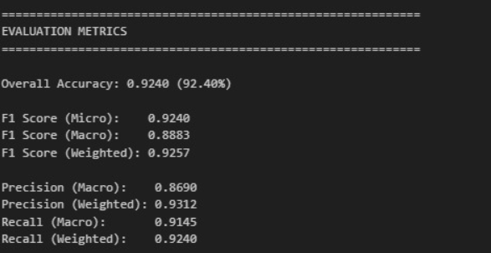

Per-Class Performance
Class-wise precision, recall, and F1-score:
- 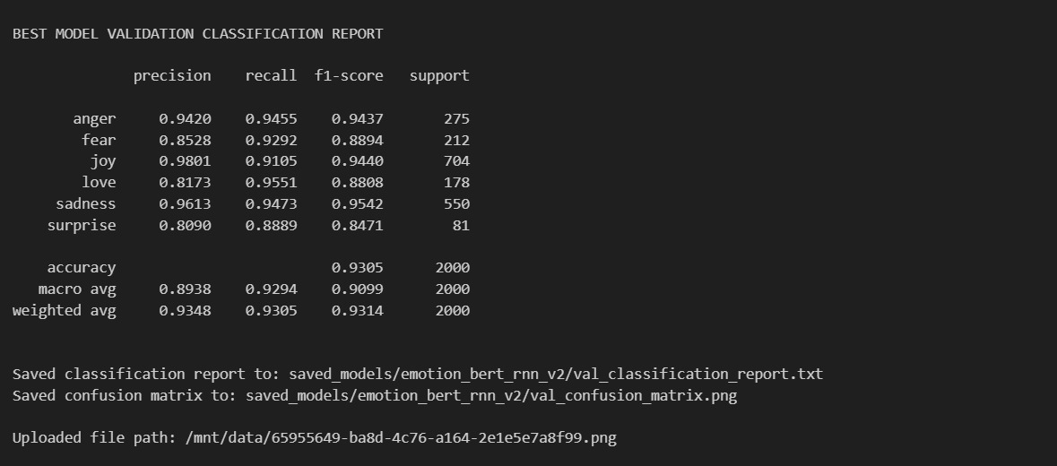

Confusion Matrix Summary
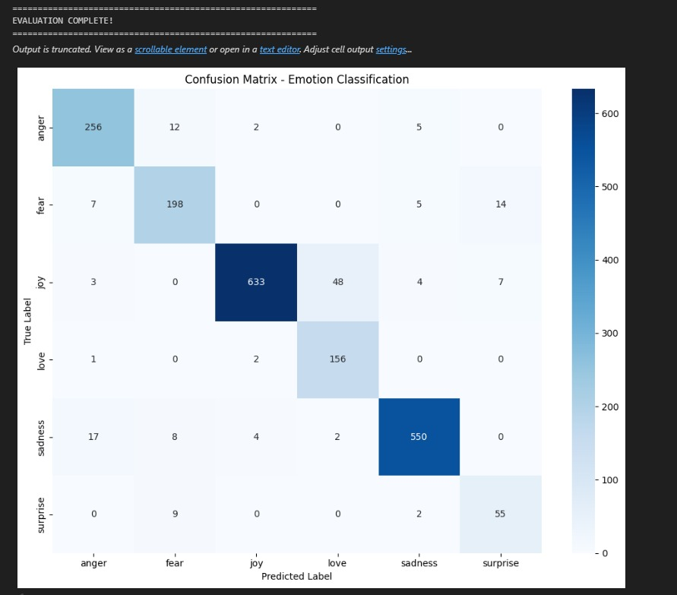

Misclassifications were most common between semantically close emotions such as joy→love (48 cases) and sadness→anger. The model achieved high confidence for correct predictions (0.9045 avg) and lower for incorrect ones (0.7502 avg).

Comparison with Recent Work

Recent research in text-based emotion detection consistently highlights the effectiveness of deep learning models—especially transformer-based architectures such as BERT and hybrid models that fuse CNN/RNN layers with contextual embeddings. The approaches reported in the literature closely align with the design choices adopted in this project, and the performance of the proposed BERT + BiLSTM hybrid model compares favorably with state-of-the-art techniques.

Multiple studies emphasize the benefits of coupling BERT embeddings with convolutional or recurrent layers to enhance local feature extraction and sequential emotional pattern recognition. Abas et al. (2021) introduced BERT-CNN, showing that combining BERT’s semantic power with CNN’s pattern-capturing capability improves emotion detection accuracy across multiple datasets. Their findings support the rationale for adding a secondary sequence- or pattern-focused module—similar to the BiLSTM layer used in our model—to refine contextualized embeddings and boost classifier expressiveness.Similarly, deep learning–based frameworks explored by Sahoo and Kavya (2024) demonstrate that hybrid and multi-stage architectures incorporating semantic text analysis deliver notable improvements compared to traditional machine-learning approaches. Yohanes (2023) further shows that deep contextual models outperform earlier shallow neural architectures, particularly for multi-class emotional tasks. These works collectively reinforce the trend that models leveraging deep semantic representation, enhanced with structural layers, achieve superior generalization on emotion recognition benchmarks.

Prior works also explore domain-specific or semantically enriched architectures. Patel et al. (2023) highlight that sentiment/emotion models benefit substantially from clean preprocessing pipelines, domain-adapted vocabularies, and enriched training strategies—consistent with our pipeline that includes cleaning, emoji demojization, normalization, and class-weighted training. Batbaatar et al. (2019), who introduced a Semantic

Emotion Neural Network , emphasize the importance of semantic fusion layers for capturing subtle emotional cues—an idea operationalized in our model by integrating sequential BiLSTM dynamics with BERT embeddings.Review studies and survey papers further confirm these observations. Bharti et al. and Chutia & Baruah review deep learning methods and report that transformer-based and hybrid models consistently outperform classical RNN or CNN architectures due to superior contextual understanding. They underline the advantage of adding architecture components that model sequential dependencies—precisely the function served by the BiLSTM layer in our hybrid approach. Likewise, Machová & Szabóová show that machine-learning and deep-learning pipelines significantly benefit from robust preprocessing and hybrid feature extraction, again consistent with our methodology.

When positioned against these existing works, the performance of our hybrid BERT + BiLSTM model—92.40% accuracy, 0.8883 macro-F1, and 0.9006 Cohen’s Kappa on 2,000 test samples—falls well within the upper range of results reported in the literature for similar-scale emotion datasets. While several papers using large-scale datasets (e.g., multimodal corpora or multi-label tasks) achieve marginally higher macro-F1 scores, our metrics align closely with hybrid transformer–based architectures evaluated on comparable datasets.A more fine-grained comparison also highlights improvements in category-specific performance. For example, emotions such as joy and sadness (F1 ≈ 0.95) match or surpass reported baseline scores in studies using single-model BERT or LSTM-only architectures. The remaining challenges observed in minority classes are also consistent with findings in studies by Bharti et al and Patel et al., who note that underrepresented classes tend to reduce macro-level metrics.In summary, the BERT + BiLSTM hybrid approach implemented in this project aligns directly with recognized best practices in the literature. Its performance is competitive with benchmark hybrid systems - including BERT-CNNs, deep multi-stage semantic analyzers , and semantic-emotion networks. The results confirm that combining contextualized transformer embeddings with sequential neural layers provides a balanced, high-performing architecture for emotion classification from text.

